1. 
2. Don’t change .git manually.
3. Git has its own file system .git and inside this, objects dir where git stores the following objects.
4. d
   1. These objects are used by git to track files and changes in files.
   2. **Blob**: Any kind of file is stored as blob.
   3. **Tree**: To store directory info. Dir maybe empty or contain other files and/or directories.
      1. Tree is set of blobs (files) and/or other trees (dirs)
   4. **Commit**: This object is used to store different versions of our project.
   5. **Annotated Tag:** Text pointer to other commits.  
      **NOTE**: In this section, we will talk about BLOB & Commit objects.
5. **Low Level Commands**:
   1. Will use the following commands to manage BLOB, TREE objects.
   2. **git hash-object**: To create git object.
   3. **git cat-file**: To read git object.  
      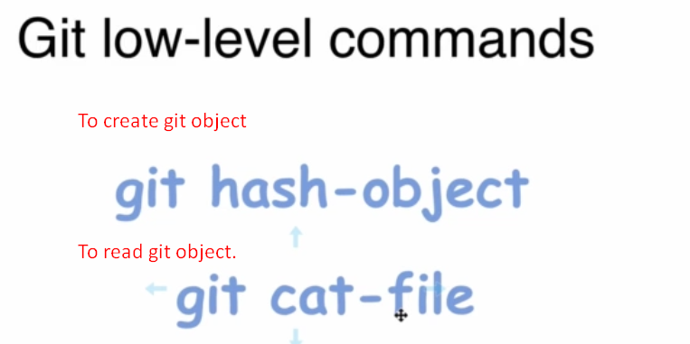  
      **NOTE**: git hash-object can create only git BLOB object.
6. Let’s see these commands in next lec.